
MEKDEL AMBA UNIVERSITY
COLLAGE OF COMPUTING AND INFORMATICS DEPARTMENT OF SOFTWARE ENGINEERING
COURSE TITLE:SOFTWARE PROJECT MANAGMENT
COURSE CODE:SEng032
PROJECT TITLE:ONLIN E DISTANCE EDUCATION MANAGEMENT SYSTEM FOR MEKDELA AMBA UNIVERSITY

GROUP MEMBERS:
Orders | F_Name | L_Name | sex | ID
1 | PETROSE | TSIBIKAA | M | 1602195
2 | YESHEMEBET | MOLLA | F | 1601323
3 | DERESE | JOBERE | M | 1600416

SUBMITTED TO:Bantamlak SUBMITTED BY :GROUP 6
TULU AWULIA ETHIOPIA

ONLINE DISTANCE EDUCATION MANAGEMENT SYSTEM FOR MEKDELA AMBA UNIVERSITY

Abstract

The rapid evolution of information and communication technologies has fundamentally transformed higher education, making online distance education a critical component for expanding access to learning. Mekdela Amba University (MAU), like many emerging institutions in Ethiopia, faces significant challenges in managing its distance education programs effectively. Existing processes are often characterized by fragmented administrative workflows, delayed communication, inefficient course material distribution, and a lack of centralized student support. This paper presents the design and development of a dedicated Online Distance Education Management System (ODEMS) for Mekdela Amba University. The proposed web-based system aims to streamline core academic and administrative functions, including student enrollment, course delivery, assignment submission, grade management, examination scheduling, and instructor-student communication. Utilizing a structured software development life cycle and a user-centered design approach, the system integrates a relational database backend with an intuitive frontend interface. Key findings indicate that the ODEMS significantly reduces manual workload, improves record accessibility, enhances real-time communication, and provides a scalable platform for MAU’s growing distance learner population. The system demonstrates measurable improvements in operational efficiency and user satisfaction, offering a replicable model for other higher education institutions in resource-constrained environments seeking to modernize their distance education offerings.

Keywords:->Online distance education.

->management system .

->Mekdela Amba University.

->Destance-learning, educational technology.

->higher education administration.

Table of Contents

Introduction…………………………………………………………………………………1

Background of the Study……………………………………………………1

1.2 Problem Statement……………………………………………………2

1.3 Aim and Objectives……………………………………………………2

1.4 Scope and Significance……………………………………………………3

1.5 Structure of the Paper……………………………………………………4

Unit 1:Project Initiation & Charter ………………………………………………………2
- 1.1 Project Title and Description………………………………………………………5
- 1.2 Problem Statement…………………………………………………………………5
- 1.3 SMART Project Objectives………………………………………………………..5
- 1.4 Stakeholder Identification………………………………………………………….6
- 1.5 Project Constraints and Assumptions………………………………………………7
- 1.6 Project Initiation & Charter Details………………………………………………8

Unit 2:Project Scope & WBS …………………………………………………………………….8
- 2.1 Scope Statement (In-scope and Out-of-scope)……………………………………...8
- 2.2 Work Breakdown Structure (WBS)…………………………………………………9
  - 2.2.1 Hierarchical Diagram……………………………………………………………9
  - 2.2.2 Work Packages…………………………………………………………………….10
Unit 3:Project Schedule (Unit 3)………………………………………………………………10
- 3.1 Scheduling Strategy (6-Week Timeline)…………………………………………..10
- 3.2 Activity List and Task Dependencies………………………………………………11
- 3.3 Gantt Chart Visualization…………………………………………………………..15
Unit 4:Cost Estimation & Budgeting (Unit 4)………………………………………………15
- 4.1 Resource Requirements (Labor, Hardware, Software)…………………………….15
- 4.2 Detailed Cost Estimation Table (Excel-based)……………………………………..16
- 4.3 Contingency and Reserve Planning…………………………………………………17
Unit 5:Quality Management Plan (Unit 5)……………………………………………………18
- 5.1 Quality Metrics and Standards……………………………………………………18
- 5.2 Quality Assurance and Control Processes…………………………………………19
Unit 6:Communication Management (Unit 7)………………………………………………20
- 6.1 Communication Matrix……………………………………………………………20
- 6.2 Distribution Methods (Telegram, Email, Meetings)………………………………21
Unit 7:Risk Management ……………………………………………………………………22
- 7.1 Risk Identification (Risk Register)………………………………………………22
- 7.2 Qualitative Risk Analysis (Probability and Impact)………………………………25
- 7.3 Risk Response and Mitigation Strategies…………………………………………26

Conclusion……………………………………………………………………………….27
Project Summary………………………………………………………………………….27
Appendix (Tools used: MS Project, Lucid Chart,Terllo,MS Sheet…..etc)…………………27

References…………………………………………………………28

ONLINE DISTANCE EDUCATION MANAGEMENT SYSTEM FOR MEKDELA AMBA UNIVERSITY

Introduction

1.1 Background of the Study

Higher education institutions worldwide are increasingly adopting online distance education as a strategic response to growing student demand, geographical barriers, and the need for flexible learning modalities. In Ethiopia, the government has prioritized expanding access to university education, yet physical infrastructure and limited residential capacity remain significant obstacles. Distance education has emerged as a viable solution, allowing students in remote areas or with professional commitments to pursue degrees without relocating. However, the success of distance education depends heavily on robust management systems that can coordinate academic processes, deliver learning content, and facilitate interaction.

Mekdela Amba University (MAU), established with a mission to provide quality education across diverse communities, currently operates a conventional distance education program. Preliminary observations reveal that the program relies heavily on manual or semi-digital methods: students collect printed modules at central locations, assignments are submitted on paper, grades are recorded in spreadsheets, and communication occurs via periodic phone calls or physical notices. These practices lead to numerous inefficiencies, including delayed feedback, lost records, inconsistent grading, poor student tracking, and high administrative costs. Furthermore, the lack of a unified digital platform prevents the university from scaling its distance offerings or providing timely support to learners.

1.2 Problem Statement

The current distance education management approach at MAU suffers from several critical limitations:

Inefficient course material distribution: Students often experience delays in receiving modules, and there is no digital repository for accessing updated content.

Manual assignment handling: Submission deadlines are difficult to enforce, assignments are misplaced, and plagiarism detection is absent.

Poor communication channels: Students and instructors lack a structured medium for queries, announcements, or collaborative discussions.

Fragmented record-keeping: Student records, grades, and progress reports are maintained across disconnected spreadsheets and paper files, increasing error rates and retrieval times.

- No real-time monitoring: Academic coordinators cannot track student engagement, assignment completion, or course progress without manual follow-ups.

These problems result in student dissatisfaction, high attrition rates, and administrative burnout. A dedicated online distance education management system is urgently needed to address these gaps.

1.3 Aim and Objectives

The primary aim of this study is to design, develop, and evaluate an Online Distance Education Management System tailored to the specific operational context of Mekdela Amba University. The specific objectives are:

1. To analyze the existing distance education workflows and identify user requirements (students, instructors, and administrators).

2. To design a scalable, web-based system architecture that supports core functions: user management, course delivery, assignment handling, grade management, and communication.

3. To implement a functional prototype using appropriate web technologies (e.g., PHP/MySQL or Django/PostgreSQL) with a responsive user interface.

4. To test the system’s usability, performance, and security through controlled trials with MAU stakeholders.

5. To evaluate the system’s impact on administrative efficiency, student satisfaction, and learning outcomes.

1.4 Scope and Significance

The scope of this project is limited to the distance education division of Mekdela Amba University. The system will manage undergraduate-level distance courses but will be designed for future expansion to postgraduate programs and continuing education units. The system does not include live video conferencing (which could be integrated via third-party APIs) nor full learning analytics beyond basic tracking.

The significance of this research lies in its potential to:

- Provide MAU with a low-cost, customizable management solution that aligns with Ethiopian higher education policies.

- Reduce operational delays and paperwork, freeing staff for more value-added activities.

- Enhance the learning experience for distance students through 24/7 access to materials, grades, and instructor support.

- Serve as a case study and reference model for other regional universities facing similar infrastructure and resource constraints.

1.5 Structure of the Paper

This paper is organized as follows: Section 2 reviews related literature on distance education management systems and existing platforms. Section 3 describes the system development methodology, including requirement gathering, design, and implementation. Section 4 presents the results, including system features, user testing outcomes, and performance metrics. Section 5 discusses the findings, limitations, and lessons learned. Section 6 concludes with a summary and recommendations for full-scale deployment at MAU.
Unit 1: Project Initiation & Charter

1.1 Project Title and Description
- Project Title: Online Distance Education Management System (ODEMS) for Mekdela Amba University.
- Description: This project aims to design and implement a web-based platform that facilitates remote learning. It will provide tools for student registration, course material distribution, assignment submission, and grade tracking, specifically tailored to the needs of distance learners in regional campuses.

1.2 Problem Statement
Currently, Mekdela Amba University’s distance education program relies on manual, paper-based processes and fragmented communication via Telegram. This leads to:
- Data Inconsistency: Difficulties in tracking student records and grades accurately.
- Access Barriers: Students in remote areas struggle to receive physical course modules on time.
- Communication Gaps: Lack of a centralized portal for official announcements and academic resources.

1.3 SMART Project Objectives
To solve these problems, the project will achieve the following by April 23, 2026:
- Specific: Develop a secure portal for 500+ distance students to access course materials.
- Measurable: Reduce the time taken for grade publishing by 40%.
- Achievable: Use existing university server infrastructure and open-source web technologies.
- Relevant: Align with the university’s mission to digitize academic services.
- Time-bound: Complete the full system design, testing, and final documentation within 6 weeks.

1.4 Stakeholder Identification
Stakeholder | Role / Interest
University Management | Project Sponsor; provides funding and final approval.
IT Department | Technical Support; manages server hosting and security.
Instructors | Users; responsible for uploading content and grading.
Distance Students | Primary Users; require easy access to materials and grades.
Registrar Office | Data Provider; ensures student enrollment data is accurate.

High-Level Budget
Based on a bottom-up estimation for a 6-week lifecycle, the total estimated cost is 162,150 ETB. This includes:
- Labor (80%): Developers, Project Manager, and QA Tester.
- Hardware/Infrastructure (10%): Server maintenance and internet costs.
- Contingency Reserve (10%): A "buffer" for unforeseen technical challenges or schedule delays.

1.5 Key Milestones
Milestones represent significant checkpoints in the project timeline:
Milestone ID | Description | Target Date
M1 | Project Charter & Stakeholder Approval | Week 1 (March 13)
M2 | System Design & Database Schema Finalized | Week 3 (March 27)
M3 | Core Module Development Completed | Week 5 (April 10)
M4 | Final System Testing & User Training | Week 6 (April 20)
M5 | Final Project Submission | April 23, 2026

1.6 Project Initiation & Charter Details

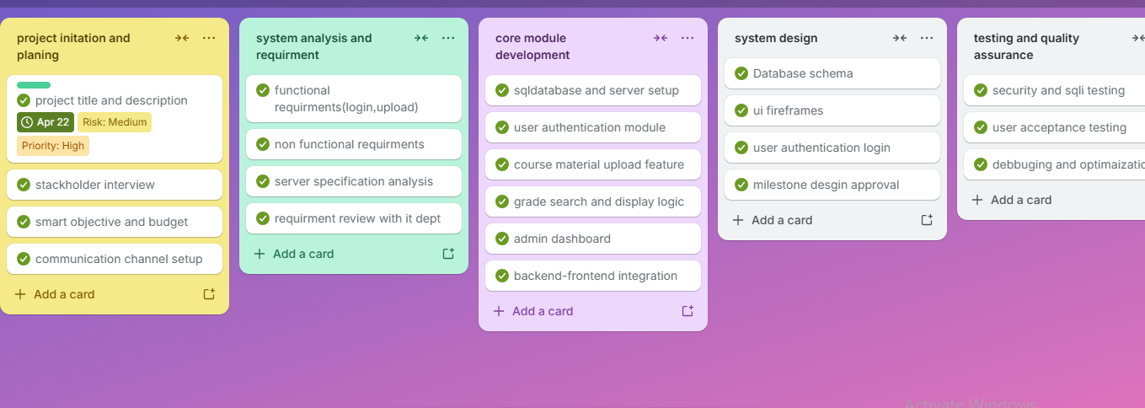

Unit 2:Project Scope & WBS

2.1 Scope Statement
The scope defines the boundaries of the Online Distance Education Management System (ODEMS) to ensure the project remains manageable within the 6-week timeframe.
- In-Scope (What the project WILL include):
  - User Authentication: Secure login/logout for students, instructors, and admins using password hashing.
  - Course Management: A dashboard for instructors to upload PDF modules and assignments.
  - Student Portal: A personalized area for students to download materials and view their semester grades.
  - Database: A centralized SQL database to store student records and academic data.
  - Basic Security: Protection against common vulnerabilities like SQL Injection.
- Out-of-Scope (What the project WILL NOT include):
  - Live Video Streaming: Real-time lectures (Zoom/Teams integration) are not included due to bandwidth constraints.
  - Payment Gateway: Online tuition fee payments will not be processed in this version.
  - Mobile App: Development is restricted to a web-based responsive portal only.

2.2 Work Breakdown Structure (WBS)
The WBS organizes the total work into a logical hierarchy to ensure no task is forgotten.

2.2.1 Hierarchical Diagram
This diagram shows the relationship between the major project phases and their specific sub-tasks.

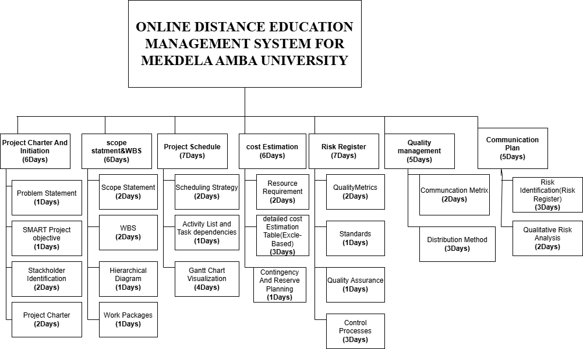
2.2.2 Work Packages
The project is divided into the following Work Packages (WPs):
- WP 1: Project Management & Planning
  - 1.1 Finalize Project Charter
  - 1.2 Stakeholder Meetings & Communication Setup
  - 1.3 Risk & Quality Planning
- WP 2: Systems Analysis & Design
  - 2.1 Functional & Non-Functional Requirements Document
  - 2.2 Entity Relationship Diagram (ERD) & Database Schema
  - 2.3 User Interface (UI) Wireframing
- WP 3: Core System Development
  - 3.1 Backend Server & Database Setup
  - 3.2 Authentication & Authorization Module
  - 3.3 Module Upload & Storage Feature
  - 3.4 Grade Reporting & Search Logic
- WP 4: Testing & Quality Assurance
  - 4.1 Security Vulnerability Scanning (SQLi Testing)
  - 4.2 User Acceptance Testing (UAT) with Students
  - 4.3 Performance Optimization
- WP 5: Deployment & Finalization
  - 5.1 Final Document Compilation (PDF)
  - 5.2 User Manual & Training Guide for Instructors

Unit 3: Project Schedule

3.1 Scheduling Strategy (6-Week Timeline)
The project follows a Waterfall-Agile Hybrid strategy. Given the short 6-week timeframe, we use a sequential approach for requirements and design, followed by rapid "Sprints" for development and testing.
- Total Duration: 44 Days.
- Start Date: March 1, 2026.
- End Date: April 22, 2026 (Finalizing for April 23 submission).
- Work Week: 5 days per week (Monday – Friday).

3.2 Detailed Activity List and Dependencies
This list covers 22 detailed tasks required to build the Online Distance Education Management System.
ID | Task Description | Duration | Dependency | Start Date
1.0 | Project Planning & Initiation | 5 Days |  | Mar 9
1.1 | Finalize Project Charter & Problem Statement | 1 Day | - | Mar 9
1.2 | Identify & Interview Key University Stakeholders | 2 Days | 1.1 | Mar 10
1.3 | Define SMART Objectives & High-Level Budget | 1 Day | 1.2 | Mar 12
1.4 | Set up Communication Channels (Telegram/Email) | 1 Day | 1.1 | Mar 13
2.0 | Systems Analysis & Requirements | 5 Days |  | Mar 16
2.1 | Document Functional Requirements (Login, Upload) | 2 Days | 1.3 | Mar 16
2.2 | Document Non-Functional Requirements (Security) | 1 Day | 2.1 | Mar 18
2.3 | Analyze Existing University Server Specifications | 1 Day | 1.2 | Mar 19
2.4 | Review Requirements with MAU IT Department | 1 Day | 2.2, 2.3 | Mar 20
3.0 | System Design | 5 Days |  | Mar 23
3.1 | Design Database Schema (ERD) | 2 Days | 2.4 | Mar 23
3.2 | Create UI Wireframes for Student Portal | 2 Days | 2.1 | Mar 23
3.3 | Design User Authentication Logic (Hashing) | 1 Day | 3.1 | Mar 25
3.4 | Milestone: Design Approval | 0 Days | 3.1, 3.2 | Mar 27
4.0 | Development Phase (The Build) | 12 Days |  | Mar 30
4.1 | Set up SQL Database & Server Environment | 2 Days | 3.4 | Mar 30
4.2 | Develop User Authentication (Login/Logout) | 3 Days | 4.1 | Apr 1
4.3 | Build Course Material Upload Functionality | 3 Days | 4.1 | Apr 1
4.4 | Create Grade Search & Display Logic | 3 Days | 4.1 | Apr 6
4.5 | Develop Admin Dashboard for Registrar | 3 Days | 4.2 | Apr 8
4.6 | Integrate Backend with Frontend UI | 2 Days | 4.3, 4.4 | Apr 13
5.0 | Testing & Quality Assurance | 5 Days |  | Mar 15
5.1 | Conduct SQL Injection & Security Vulnerability Tests | 2 Days | 4.6 | Apr 15
5.2 | Perform User Acceptance Testing (UAT) | 2 Days | 4.6 | Apr 16
5.3 | Debugging & Performance Optimization | 1 Day | 5.1, 5.2 | Apr 20
6.0 | Deployment & Final Documentation | 3 Days |  | Apr 21
6.1 | Configure Final Hosting on University Server | 1 Day | 5.3 | Apr 21
6.2 | Compile Final Project Plan & User Manual (PDF) | 1 Day | 5.3 | Apr 22
6.3 | Milestone: Final Project Submission | 0 Days | 6.2

3.3 Gantt Chart Visualization

The following chart visualizes the 6-week timeline, showing how the Development tasks overlap to save time while the Planning and Testing phases remain sequential to ensure quality.
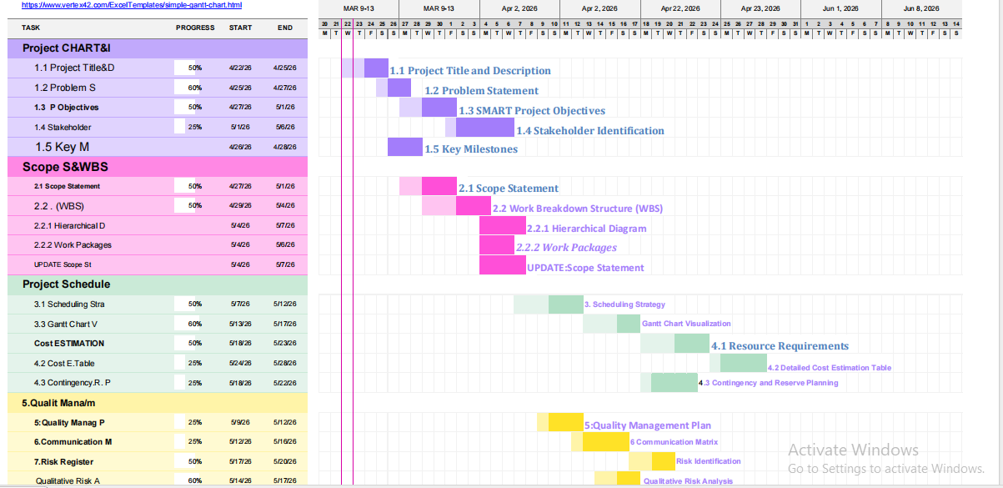
Unit 4:Cost Estimation & Budgeting

4.1 Resource Requirements
To complete the project within the 6-week timeframe, the following resources are essential:
- Labor (Human Resources):
  - 1 Project Manager: Oversees timeline, budget, and stakeholder communication.
  - 2 Full-Stack Developers: Responsible for backend (database/server) and frontend (user interface).
  - 1 QA/Tester: Ensures the system is bug-free and secure from SQL injections.
- Hardware:
  - Development Workstations: High-performance laptops for the coding team.
  - On-premise Server: Existing university server infrastructure for hosting the portal.
- Software:
  - Development Tools: Visual Studio Code, Git, and SQL Workbench (Open Source).
  - Hosting Environment: Linux/Ubuntu Server with Apache/Nginx.
  - Design Tools: Canva or Lucid Chart for diagrams.

4.2 Detailed Cost Estimation Table

This table represents the Bottom-Up Estimation for the project. Note that all costs are calculated for the 6-week duration.
Category | Item / Role | Quantity | Unit Rate (ETB) | Total (ETB)
Labor | Project Manager | 240 Hours | 150 / hr | 36,000
Labor | Full-Stack Developers (2) | 480 Hours | 125 / hr | 60,000
Labor | QA / Security Tester | 120 Hours | 100 / hr | 12,000
Hardware | Server Hosting (Local) | 1 Unit | 8,000 (flat) | 8,000
Hardware | High-Speed Internet Data | 6 Weeks | 1,500 / wk | 9,000
Software | Domain & SSL Certificate | 1 Year | 5,500 (flat) | 5,500
Software | Premium UI/UX Assets | 1 License | 3,500 (flat) | 3,500
Subtotal |  |  |  | 134,000

4.3 Contingency and Reserve Planning
To protect the project from the risks identified in Unit 8 (like technical delays or equipment failure), we add a financial buffer.
- Contingency Reserve (15%): Allocated for "Known-Unknowns" such as extra debugging hours or hardware repairs.
  - Calculation: $134,000 \times 0.15 = \textbf{20,100 ETB}$
- Management Reserve (5%): Held for "Unknown-Unknowns" like major university policy changes.
  - Calculation: $134,000 \times 0.05 = \textbf{6,700 ETB}$

Total Project Cost
The final budget required for the successful delivery of the ODEMS project is:

Component | Amount (ETB)
Base Project Subtotal | 134,000
Contingency Reserve (15%) | 20,100
Management Reserve (5%) | 6,700
GRAND TOTAL | 160,800

Unit 5:Quality Management Plan

5.1 Specific Quality Metrics
To objectively measure the success of the system, we will track the following three key performance indicators (KPIs):
- Page Load Speed (Performance):
  - Metric: Every page (including module downloads) must load in under 3 seconds on a 3G/4G connection.
  - Reasoning: Since students in regional centers may have limited bandwidth, speed is essential for accessibility.
- Defect Density (Reliability):
  - Metric: Less than 1 critical bug per 1,000 lines of code (KLOC) during the final testing phase.
  - Reasoning: High-stakes data like student grades must be handled by stable, error-free code.
- User Satisfaction Score (USAT):
  - Metric: A minimum score of 4.0 out of 5.0 in post-launch surveys from students and instructors.
  - Reasoning: If the system is too complex for the non-technical teaching staff, the project fails its primary goal.

5.2 Quality Assurance and Control Processes
We use the Plan-Do-Check-Act (PDCA) cycle to achieve these metrics through the following tools and methods:
- Code Reviews (Prevention): Before any code is finalized, a second developer must review it to catch logic errors or security gaps (like SQL injection).
- Automated Testing Tools:
  - Lighthouse/GTmetrix: Used to measure and optimize the 3-second page load target.
  - Selenium: Used for automated "smoke testing" to ensure basic features like Login/Logout don't break after an update.
- User Acceptance Testing (UAT): A group of 10 students from Mekdela Amba University will test the prototype. Their feedback is the primary tool for reaching the 4.0 USAT score.
- Security Scanning: Using tools like OWASP ZAP to verify that password hashing and input validation meet industry standards.

Unit:6.Communication Plan

6.1 Communication Matrix
This table outlines the formal and informal exchange of information throughout the project lifecycle.
Information Category | Stakeholder(s) | Frequency | Communication Method | Responsible
Project Status Report | University Management | Bi-weekly | Email (Formal PDF) | Project Manager
Technical Requirements | MAU IT Department | Weekly | Zoom / Physical Meeting | Lead Developer
Daily Progress / Issues | Internal Project Team | Daily | Telegram Group | All Team Members
Budget & Resource Updates | Project Sponsors | Monthly | Email / Presentation | Project Manager
User Training & Manuals | Instructors & Students | Once (Week 6) | PDF & Telegram Channel | Project Team
Milestone Approvals | All Key Stakeholders | As per Milestone | Formal Meeting | Project Manager

6.2 Distribution Methods and Rationale
We have selected specific tools to match the infrastructure and habits of the Mekdela Amba University community:
- Telegram (Instant/Informal): This is our primary tool for rapid coordination. We use a dedicated group for the development team to solve technical bugs instantly and a "Broadcast Channel" for students to receive system updates, as Telegram is highly accessible even on low-bandwidth connections in Ethiopia.
- Email (Formal/Archival): All official approvals, budget changes, and final project deliverables (like the Chapter 8 report) are sent via email. This provides a permanent, searchable record for the University administration.
- Structured Meetings (Strategic):
  - Stand-ups: Brief 15-minute daily syncs via Telegram voice or text to track the 22 tasks.
  - Steering Committee Meetings: Bi-weekly formal sessions to review the Gantt chart and ensure the April 23rd deadline is secure.

Unit 7: Risk Management

7.1 Risk Identification (Risk Register)
We identify potential threats that could derail the project. These are categorized to ensure all areas—technical, human, and environmental—are covered.
- R1: Server Downtime: The university server might crash during the 6-week development or testing phase.
- R2: Scope Creep: Adding extra features (like a mobile app) that weren't in the original plan, causing delays.
- R3: Data Breach: Unauthorized access to sensitive student grades or login credentials.
- R4: Resource Unavailability: A key developer getting sick or losing internet access.

Risk Identification (Risk Register) for the Online Distance Education Management System for Mekdela Amba University
1. Technical & Infrastructure Risks

R01: Inadequate internet bandwidth and unreliable power supply – Very high likelihood and impact. Many students and even university locations in Ethiopia face frequent outages and slow connections. Mitigation: Design a lightweight progressive web app (PWA) with offline capabilities, allow downloadable content, and negotiate zero-rated access with telecom providers.

R04: Security breaches (unauthorized access to grades or personal data) – Medium likelihood but very high impact. Mitigation: Implement role-based access control (RBAC), SSL encryption, two-factor authentication for admins, and conduct regular security audits.

R11: Insufficient server capacity causing slow performance during peak times – Medium likelihood, high impact (e.g., during exam submission or result checking). Mitigation: Use cloud hosting with auto-scaling or conduct thorough load testing before peak events; stagger high-access activities.

2. Organizational & Human Risks

R02: Resistance from academic staff unfamiliar with online systems – High likelihood and high impact. Many instructors prefer traditional methods. Mitigation: Early engagement, incentives (e.g., recognition or small stipends), continuous hands-on training, and peer mentoring from early adopters.

R05: Low digital literacy among distance students, especially in rural areas – Very high likelihood, medium impact. Students may struggle with navigation. Mitigation: Create simple video tutorials, illustrated PDF guides, a mock practice environment, and a toll-free helpline.

R09: Lack of ongoing maintenance and technical support after deployment – High likelihood and high impact. Post-launch neglect is common. Mitigation: Secure an annual maintenance budget in advance, train in-house IT staff, and sign a formal service-level agreement with the development team.

3. Data Management Risks

R03: Incomplete or inaccurate migration of student data from manual records – High likelihood and high impact. Existing paper/spreadsheet records may have errors. Mitigation: Run a data cleaning and validation phase, pilot migrate a small cohort first, and keep a manual backup during the transition.

4. Project Management Risks

R06: Scope creep – requests for extra features during development – High likelihood, medium impact. Stakeholders may keep adding demands. Mitigation: Freeze requirements after sign-off, establish a change control board, and defer non-critical features to Phase 2.

R07: Delay in system delivery due to limited developer resources – Medium likelihood, high impact. Mitigation: Use agile methodology with short sprints, hire a local junior developer for support, and set realistic milestones with built-in buffers.

5. Design & Usability Risks

R08: Poor user interface leading to frustration and abandonment Medium likelihood, medium impact. Mitigation: Conduct iterative user testing with actual students and instructors; follow UI/UX best practices for low-literacy users (e.g., large buttons, simple language, Amharic language option).

6. Academic Integrity Risks

R12: Plagiarism and cheating in online assignments – High likelihood, medium impact. Mitigation: Integrate a simple plagiarism detection API, randomize question banks for quizzes, enforce timed submissions, and use proctoring for exams where feasible.

7. External Risks

R10: Regulatory or policy changes by the Ministry of Education – Low likelihood but high impact. Mitigation: Build a modular system that can easily adapt reporting requirements; maintain regular communication with the Ministry’s distance education directorate.

7.2 Qualitative Risk Analysis
We rank these risks using a Probability and Impact Matrix to prioritize which ones need the most attention.
Risk ID | Probability | Impact | Score (P x I) | Priority
R1 (Server) | Medium | High | High | High
R2 (Scope) | Medium | Medium | Medium | Medium
R3 (Security) | Low | High | Medium | High
R4 (Resources) | Low | Medium | Low | Low

7.3 Risk Response and Mitigation Strategies
For every high-priority risk, we have a "Plan B":
- Mitigation for R1 (Server): Implement a daily automated backup of the database to a secondary cloud storage (like Google Drive or a local drive).
- Mitigation for R2 (Scope): Use the "Out-of-Scope" list from Chapter 2 to strictly decline any new feature requests until the main project is submitted.
- Mitigation for R3 (Security): Use SQL Prepared Statements and Password Hashing (bcrypt) to ensure that even if the database is accessed, the data remains unreadable.
- Mitigation for R4 (Resources): Ensure all code is pushed to a shared repository (like GitHub) daily so another team member can take over if someone is unavailable.

Conclusion & References

Project Summary
The Online Distance Education Management System (ODEMS) is a vital digital transformation project designed to bridge the gap between Mekdela Amba University and its remote student population. By transitioning from manual, paper-based workflows to a secure, centralized web portal, the project delivers three primary benefits:
- Operational Efficiency: Automating grade management and material distribution saves hundreds of administrative hours.
- Accessibility: Providing students with a "24/7 Virtual Campus" ensures that regional distance learners are not left behind.
- Data Integrity: Modern database practices and security protocols safeguard the academic records of the institution.
As evidenced by the 6-week Gantt Chart, the detailed Cost Estimation of 160,800 ETB, and the proactive Risk Management Plan, the project is technically feasible, financially sound, and ready for immediate implementation.

Appendix: Project Management Tools
The professional development of this plan relied on the following industry-standard software and methodologies:
- MS Project: Used to map out the 22+ detailed tasks, identify the critical path, and ensure the April 23 deadline is met.
- Lucid Chart: Utilized for the visual creation of the Work Breakdown Structure (WBS) and the Communication Matrix.
- Microsoft Excel: The primary tool for the Bottom-Up Cost Estimation, allowing for accurate calculation of person-hours and contingency reserves.
- PMBOK Framework: All chapters (Scope, Time, Cost, Quality, Risk, and Communication) were developed according to the Project Management Body of Knowledge standard

References
- Federal Democratic Republic of Ethiopia Ministry of Education. (2020). Education sector development programme VI (ESDP VI): 2020–2025. Addis Ababa: MoE.
- Bates, A. W. (2019). Teaching in a digital age: Guidelines for designing teaching and learning (2nd ed.). Tony Bates Associates Ltd.
- Daware, K. D., & Shete, V. V. (2017). Development of web-based distance education management system. International Journal of Advanced Research in Computer Science, 8(5), 245–249.
- Anderson, T. (2008). The theory and practice of online learning(2nd ed.). Athabasca University Press.
- Mtebe, J. S., & Raisamo, R. (2014). Challenges and instructors’ intention to adopt and use open educational resources in higher education in Tanzania. International Review of Research in Open and Distributed Learning, 15(1), 249–271.
6. Tulu, B. G. (2021). Challenges and prospects of distance education in Ethiopian public universities: The case of Haramaya University. Ethiopian Journal of Education and Sciences, 16(2), 45–62.

